**1.Outline of the differences between transducers, sensors, and actuators**

**Outline of the Differences Between Transducers, Sensors, and Actuators**

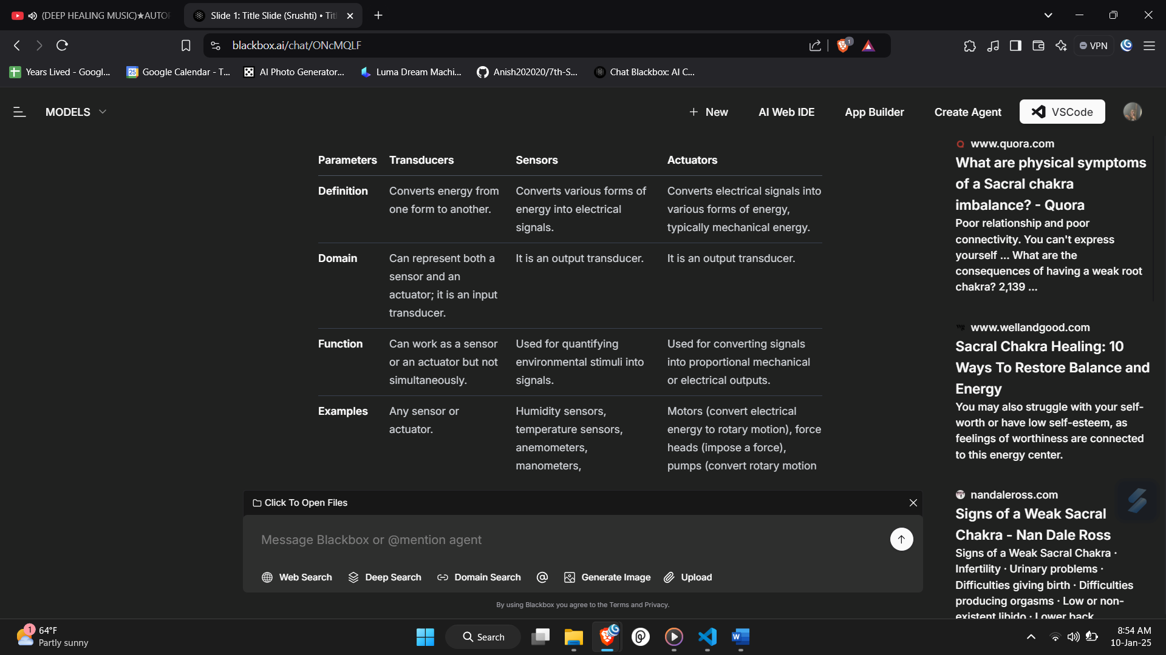

**2. Explain simple sensing operation  
Simple Sensing Operation**

A simple sensing operation involves the process by which a sensor detects changes in the environment and communicates this information for further processing or monitoring. Below is an explanation of the components and steps involved in a typical simple sensing operation:

**Components of a Simple Sensing Operation**

1. **Sensor**:
   * The device that detects a specific physical phenomenon (e.g., temperature, pressure, light) and converts it into an electrical signal.
   * Example: A temperature sensor that measures the ambient temperature.
2. **Processor**:
   * A unit that receives the signals from the sensor, processes the data, and makes decisions based on predefined criteria.
   * Example: A microcontroller that interprets the temperature readings.
3. **Communication Module**:
   * A component that transmits the processed data to a remote monitoring system or other devices.
   * Example: A Wi-Fi or Bluetooth module that sends data to a cloud server or a mobile application.
4. **Monitoring System**:
   * The system that receives the data from the processor and displays or analyzes it for user interaction.
   * Example: A dashboard on a computer or mobile device that shows real-time temperature readings.

**Steps in a Simple Sensing Operation**

1. **Sensing**:
   * The sensor continuously monitors the environment for changes in the specific property it is designed to measure (e.g., temperature).
   * When a change occurs (e.g., an increase in temperature due to a fire), the sensor detects this change.
2. **Signal Conversion**:
   * The sensor converts the detected physical phenomenon into an electrical signal. For example, a temperature sensor may produce a voltage output that corresponds to the temperature reading.
3. **Data Transmission**:
   * The electrical signal is sent to the processor for further analysis. The processor may perform tasks such as filtering, scaling, or calibrating the signal.
4. **Processing**:
   * The processor analyzes the received signal and determines if it meets certain criteria (e.g., if the temperature exceeds a predefined threshold).
5. **Communication**:
   * If the criteria are met (e.g., the temperature is too high), the processor sends a notification or alert through the communication module to the monitoring system.
6. **Monitoring**:
   * The monitoring system receives the data and displays it to the user. In the case of an alert, it may trigger an alarm or send a notification to the user’s device.

**Example of a Simple Sensing Operation**

Consider a temperature sensing operation in a fire detection system:

* **Sensing**: A temperature sensor continuously monitors the room temperature.
* **Signal Conversion**: The sensor detects a rise in temperature and converts it into an electrical signal.
* **Data Transmission**: The signal is sent to a microcontroller.
* **Processing**: The microcontroller checks if the temperature exceeds a safe limit (e.g., 75°C).
* **Communication**: If the limit is exceeded, the microcontroller sends an alert to a connected alarm system.
* **Monitoring**: The alarm system activates, notifying occupants of the potential fire hazard.

**3. Explain with diagram functional blocks of a typical sensor node in IoT  
Functional Blocks of a Typical Sensor Node in IoT**

A sensor node in the Internet of Things (IoT) is a critical component that collects data from the environment and communicates it to other devices or systems. The functional blocks of a typical sensor node include various components that work together to perform sensing, processing, communication, and power management. Below is an explanation of these functional blocks along with a diagram.

**Functional Blocks**

1. **Sensor**:
   * **Description**: The sensor is responsible for detecting physical phenomena (e.g., temperature, humidity, light) and converting them into electrical signals.
   * **Example**: Temperature sensor, humidity sensor, gas sensor, etc.
2. **Processor**:
   * **Description**: The processor (microcontroller or microprocessor) processes the data received from the sensor. It performs tasks such as data filtering, analysis, and decision-making.
   * **Example**: ARM Cortex, Arduino, Raspberry Pi.
3. **Communication Module**:
   * **Description**: This module enables the sensor node to communicate with other devices or networks. It can use various communication protocols such as Wi-Fi, Bluetooth, Zigbee, LoRa, etc.
   * **Example**: Wi-Fi module (ESP8266), Bluetooth module (HC-05), Zigbee module (XBee).
4. **Power Unit**:
   * **Description**: The power unit supplies energy to the sensor node. It can be powered by batteries, solar panels, or other energy sources. Power management is crucial for ensuring the longevity of the sensor node.
   * **Example**: Lithium-ion battery, solar panel.
5. **Data Storage**:
   * **Description**: Some sensor nodes may include data storage components to temporarily store data before processing or transmission. This can be useful for buffering data during communication interruptions.
   * **Example**: EEPROM, SD card.
6. **Interface**:
   * **Description**: The interface allows for user interaction or configuration of the sensor node. It can include buttons, displays, or other input/output devices.
   * **Example**: LCD display, push buttons.
7. **Actuator (Optional)**:
   * **Description**: In some sensor nodes, actuators may be included to perform actions based on the processed data (e.g., turning on a fan when a temperature threshold is exceeded).
   * **Example**: Relay, motor.

**4. Explain the sensor Characteristics.  
Sensor Characteristics**

Sensors are critical components in IoT systems, and their performance is defined by several key characteristics. Understanding these characteristics is essential for selecting the right sensor for a specific application. Below are the primary characteristics of sensors:

1. **Sensor Resolution**:
   * **Definition**: The smallest change in the measurable quantity that a sensor can detect.
   * **Importance**: Higher resolution allows for more precise measurements. For example, a temperature sensor with a resolution of 0.1°C can detect smaller changes than one with a resolution of 1°C.
2. **Sensor Accuracy**:
   * **Definition**: The degree to which a sensor's measurement corresponds to the true value of the quantity being measured.
   * **Importance**: Accuracy is crucial for applications where precise measurements are required. For instance, a weight sensor that measures 100 kg as 99.98 kg is considered highly accurate.
3. **Sensor Precision**:
   * **Definition**: The ability of a sensor to provide consistent measurements under the same conditions. It reflects the repeatability of the sensor's output.
   * **Importance**: A sensor can be precise but not accurate if it consistently measures the same value that is far from the true value. For example, if a weight sensor gives readings of 98.5 kg, 99.0 kg, and 99.5 kg for a 100 kg mass, it is not precise.
4. **Sensitivity**:
   * **Definition**: The ratio of the change in output signal to the change in the measured quantity. It indicates how responsive a sensor is to changes in the input.
   * **Importance**: High sensitivity is desirable for detecting small changes in the measured property. For example, a highly sensitive pressure sensor can detect minute changes in atmospheric pressure.
5. **Linearity**:
   * **Definition**: The degree to which the output of a sensor is directly proportional to the input over a specified range.
   * **Importance**: A linear sensor provides a consistent relationship between input and output, making it easier to interpret measurements. Non-linear sensors may require complex calibration.
6. **Hysteresis**:
   * **Definition**: The difference in sensor output when the input is increasing versus when it is decreasing. It indicates the lag in the sensor's response.
   * **Importance**: Low hysteresis is preferred for applications requiring quick and accurate responses. High hysteresis can lead to inaccuracies in measurements.
7. **Drift**:
   * **Definition**: The gradual change in sensor output over time, even when the input remains constant. It can be caused by environmental factors or aging of the sensor.
   * **Importance**: Drift can lead to long-term inaccuracies in measurements, making regular calibration necessary.
8. **Dynamic Response**:
   * **Definition**: The ability of a sensor to respond to changes in the measured quantity over time. It includes parameters like rise time, fall time, and settling time.
   * **Importance**: Sensors with fast dynamic response are essential for applications that require real-time monitoring and quick reactions to changes.
9. **Operating Range**:
   * **Definition**: The range of values over which a sensor can accurately measure a quantity. It includes minimum and maximum limits.
   * **Importance**: Selecting a sensor with an appropriate operating range is crucial to ensure accurate measurements without exceeding the sensor's limits.

**5. What are Actuators? explain its types.**

**Actuators**

Actuators are devices that convert electrical signals into physical motion or action. They play a crucial role in IoT systems by enabling control over various processes and mechanisms. Actuators are essential for applications that require physical movement or the manipulation of objects based on the data received from sensors or control systems.

**Types of Actuators**

Actuators can be classified into several types based on their operating principles and the form of energy they use. Below are the main types of actuators:

1. **Hydraulic Actuators**:
   * **Description**: Hydraulic actuators use pressurized fluid to create motion. They are capable of generating significant force and are commonly used in heavy machinery and industrial applications.
   * **Function**: The mechanical motion applied to a hydraulic actuator can be linear, rotary, or oscillatory.
   * **Example**: Hydraulic cylinders used in construction equipment for lifting heavy loads.
2. **Pneumatic Actuators**:
   * **Description**: Pneumatic actuators operate using compressed air or gas to produce motion. They are known for their quick response times and are often used in applications requiring rapid actuation.
   * **Function**: Similar to hydraulic actuators, pneumatic actuators can produce linear or rotary motion.
   * **Example**: Pneumatic valves used in automated systems for controlling fluid flow.
3. **Electrical Actuators**:
   * **Description**: Electrical actuators use electric motors to generate mechanical motion. They are widely used due to their simplicity, cleanliness, and ease of control.
   * **Function**: Electric actuators can provide precise control over motion and are often used in robotics and automation.
   * **Example**: Servo motors and stepper motors used in robotic arms and CNC machines.
4. **Thermal or Magnetic Actuators**:
   * **Description**: These actuators use thermal or magnetic energy to create motion. They are typically compact and lightweight.
   * **Function**: Thermal actuators can change shape or position in response to temperature changes, while magnetic actuators use magnetic fields to produce motion.
   * **Example**: Shape memory alloys (SMAs) that change shape when heated.
5. **Mechanical Actuators**:
   * **Description**: Mechanical actuators convert rotary motion into linear motion using mechanical components such as gears, pulleys, and levers.
   * **Function**: They are often used in conjunction with other types of actuators to achieve desired movements.
   * **Example**: Rack and pinion mechanisms used in steering systems.
6. **Soft Actuators**:
   * **Description**: Soft actuators are made from flexible materials and can deform to produce motion. They are designed to handle delicate tasks and are often used in robotics and biomedical applications.
   * **Function**: They can mimic natural movements and are suitable for applications requiring gentle handling.
   * **Example**: Soft robotic grippers used for picking fruits without damaging them.
7. **Shape Memory Polymers (SMPs)**:
   * **Description**: SMPs are smart materials that can change shape in response to external stimuli such as temperature, light, or magnetic fields.
   * **Function**: They can be programmed to return to a predetermined shape when activated.
   * **Example**: SMP-based actuators used in medical devices that expand or contract in response to body temperature.